Keeping Minneapolis Safe Is About to Get Much Harder

A federal consent decree will make policing more difficult and expensive without reducing crime.
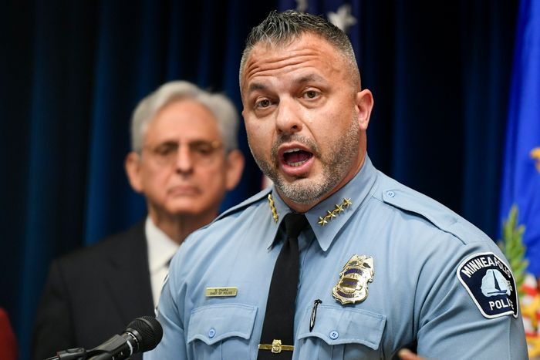
The Justice Department announced last week that the Minneapolis Police Department will operate under a federal consent decree. An investigation sparked by the 2020 killing of George Floyd determined that the city unlawfully discriminates against blacks and Native Americans in its enforcement activities. The terms of federal oversight are yet to be negotiated, but Minneapolis officials should think twice before signing on the dotted line. These agreements typically make effective policing more difficult and expensive without significantly reducing crime.
There’s no doubt that Minneapolis is in crisis. Police resignations and retirements have shrunk the number of sworn officers by 35% since the unrest of 2020. While the city’s 2023 budget contains funding for 731 officers to protect and serve Minneapolis’s 425,000 residents, the department currently only has 571 officers—496 of whom are assigned to the division that answers 911 calls. And while the post-Floyd upsurge of violence ebbed slightly in 2022, Minneapolis is still a much more dangerous city than it was a few years ago. Last year the number of homicides was 65% higher than in 2019, while reports of gunfire and the number of shooting victims doubled over that period.
Still, the Justice Department’s report on Minneapolis is flawed. Minneapolis police responded to more than a million calls for assistance from 2016-22, but federal officials could cite fewer than 20 specific instances of alleged misconduct. To establish the existence of what the feds call “a pattern or practice of discrimination,” investigators point to racial disproportionality in police statistics. “Based on our review of the data, MPD officers stop, search, and then use force against people who are black and Native American at disproportionate rates,” Attorney General Merrick Garland said at a June 16 press conference.
Advertisement - Scroll to Continue
But a difference doesn’t prove discrimination. Any serious criminologist or statistician would test other variables before concluding that race explains the variation in police interactions. While black and Native American Minneapolis residents are more likely to encounter police, they are also more than three times as likely as other residents to be victims. Without adjusting for where and when the offense occurred and who was the victim, the Justice Department is guilty of cherry-picking facts to fit its conclusion. As I learned while helping to negotiate a consent decree in Baltimore, it’s important for cities to push back at the beginning of this process. It could be the last chance they get.
Consent decrees are often open-ended and can drag on for a decade or longer. Both Seattle and New Orleans are in their 11th year of federal oversight despite long ago meeting the initial benchmarks of their agreements. Since departmental compliance is often ill-defined or arbitrary, federal monitors and judges can move the goal posts. In Albuquerque, N.M., the latest monitors’ report deemed the department to be 92% operationally compliant, conveniently shy of the 95% threshold, which would make the monitors redundant.
New Orleans Mayor LaToya Cantrell petitioned a federal court in August 2022 to lift her city’s agreement, saying the monitors’ arbitrary decisions and delays prove “the objective goals of the Decree have all but vanished.” The monitors won’t let go. In March they accused New Orleans of “backsliding” on reforms and “slippage in compliance.” The judge overseeing the agreement delayed considering the city’s petition for 10 months. With no decision date set, the consent decree drags on.
The cost of implementation and monitoring these agreements is exorbitant. Seattle’s decade-long saga has cost taxpayers $200 million. In Chicago, which had its original five-year consent decree extended by three years in March, officials expect the final price tag to reach at least $100 million. Louisville, Ky., has allocated $8 million to $10 million a year (which will certainly balloon) for its pending agreement, which is equal to 5% of the city’s police budget. Mr. Garland recognized the runaway spending in 2021 and ordered a cap on monitors’ fees.
In city after city, federal consent decrees have failed to achieve their aims and often proved counterproductive. Surveys show the majority of police support significant reforms, including the use of body-worn cameras, crisis-response teams and improved communications and de-escalation training, but heavy-handed consent decrees can sap morale. Weighed down by excessive paperwork and wary of undue scrutiny, officers’ on-duty performance suffers and many choose to quit or retire. Fewer qualified candidates are willing to join, creating a staffing crisis.
When the federal government truly needs to step in and help reform a police department via consent decree, that agreement should focus on the most urgent concerns. Its proposals should be backed by rigorous evidence. It should set realistic benchmarks for reform and hold police and city leadership accountable for timely and effective execution. But experience teaches that things rarely work that way.
Mr. Johnson is president of the Law Enforcement Legal Defense Fund. As deputy police commissioner in Baltimore, 2016-18, he oversaw the department’s consent decree negotiations and implementation.

